# Bahria University,

## Karachi Campus



LAB EXPERIMENT NO.

**_04_**

LIST OF TASKS

|  |  |
| --- | --- |
| **TASK NO** | **OBJECTIVE** |
| 01 | Create a simple app with a button and a text view. When the button is clicked, display a toast message saying, "Button Clicked". |
| 02 | Create an app with an edit text field and a button. When the button is clicked, check if the edit text is empty. If it's empty, show an error message, otherwise display the entered text in a toast message. |
| 03 | Create an app with checkbox and a text view. When the checkbox state changes, update the text view to display "Checked" if the checkbox is checked, and "Unchecked" if it's unchecked. |

Submitted On:

Date: 04/04/2024

**Task No 01:** Create a simple app with a button and a text view. When the button is clicked, display a toast message saying, "Button Clicked".

**Solution:**

package com.example.assignment1;  
import androidx.appcompat.app.AppCompatActivity;  
import android.os.Bundle;  
import android.view.View;  
import android.widget.Button;  
import android.widget.EditText;  
import android.widget.RadioButton;  
import android.widget.RadioGroup;  
import android.widget.Toast;  
import android.widget.CheckBox;  
public class MainActivity extends AppCompatActivity {  
 @Override  
 protected void onCreate(Bundle savedInstanceState) {  
 super.onCreate(savedInstanceState);  
 setContentView(R.layout.*activity_main*);  
  
 EditText username=findViewById(R.id.*editUser*);  
 Button button=findViewById(R.id.*login*);  
  
 button.setOnClickListener(new View.OnClickListener(){  
 @Override  
 public void onClick(View v){  
 Toast.*makeText*(MainActivity.this,"Button Clicked",Toast.*LENGTH_SHORT*).show();}});}}

**Output:**

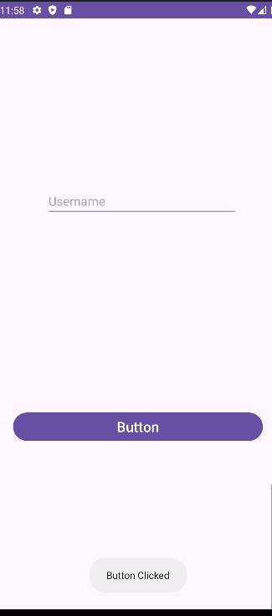

**Task No 02:** Create an app with an edit text field and a button. When the button is clicked, check if the edit text is empty. If it's empty, show an error message, otherwise display the entered text in a toast message.

**Solution:**

package com.example.assignment1;  
import androidx.appcompat.app.AppCompatActivity;  
import android.os.Bundle;  
import android.view.View;  
import android.widget.Button;  
import android.widget.EditText;  
import android.widget.RadioButton;  
import android.widget.Toast;  
public class MainActivity extends AppCompatActivity {  
 @Override  
 protected void onCreate(Bundle savedInstanceState) {  
 super.onCreate(savedInstanceState);  
 setContentView(R.layout.*activity_main*);  
 EditText username=findViewById(R.id.*editUser*);  
 Button button=findViewById(R.id.*login*);  
 button.setOnClickListener(new View.OnClickListener(){  
 String userName=username.getText().toString();  
 @Override  
 public void onClick(View v){  
 if(userName.isEmpty()){  
 Toast.*makeText*(MainActivity.this, "ERROR: Username is not write", Toast.*LENGTH_SHORT*).show();  
 }else {  
 Toast.*makeText*(MainActivity.this, userName, Toast.*LENGTH_SHORT*).show();  
 }  
 }});}}

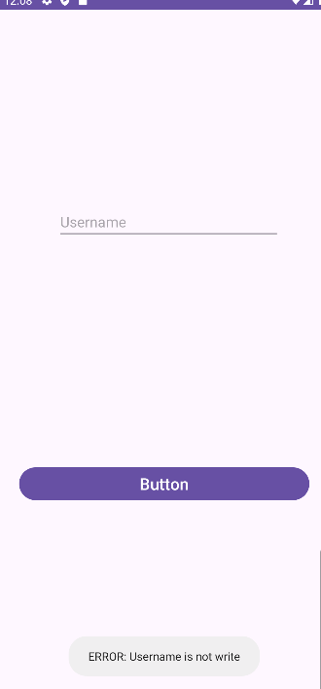**Output:**

**Task No 03:** Create an app with checkbox and a text view. When the checkbox state changes, update the text view to display "Checked" if the checkbox is checked, and "Unchecked" if it's unchecked.

**Solution:**

package com.example.assignment1;  
import androidx.appcompat.app.AppCompatActivity;  
import android.os.Bundle;  
import android.view.View;  
import android.widget.Button;  
import android.widget.CompoundButton;  
import android.widget.EditText;  
import android.widget.Toast;  
import android.widget.CheckBox;  
public class MainActivity extends AppCompatActivity {  
 @Override  
 protected void onCreate(Bundle savedInstanceState) {  
 super.onCreate(savedInstanceState);  
 setContentView(R.layout.*activity_main*);  
 CheckBox checkBox=findViewById(R.id.*checkBox*);  
 EditText textView=findViewById(R.id.*editUser*);  
 checkBox.setOnCheckedChangeListener(new CompoundButton.OnCheckedChangeListener() {  
 @Override  
 public void onCheckedChanged(CompoundButton buttonView, boolean isChecked) {  
 if(isChecked){  
 textView.setText("Checked");}  
 else{  
 textView.setText("UnChecked");}}});}}

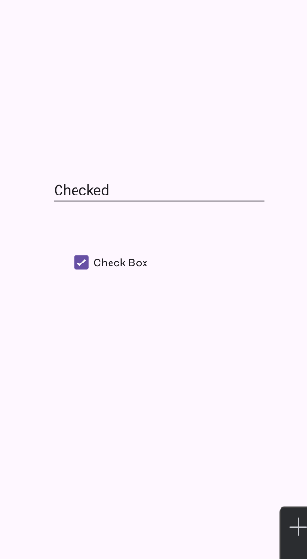**Output:**